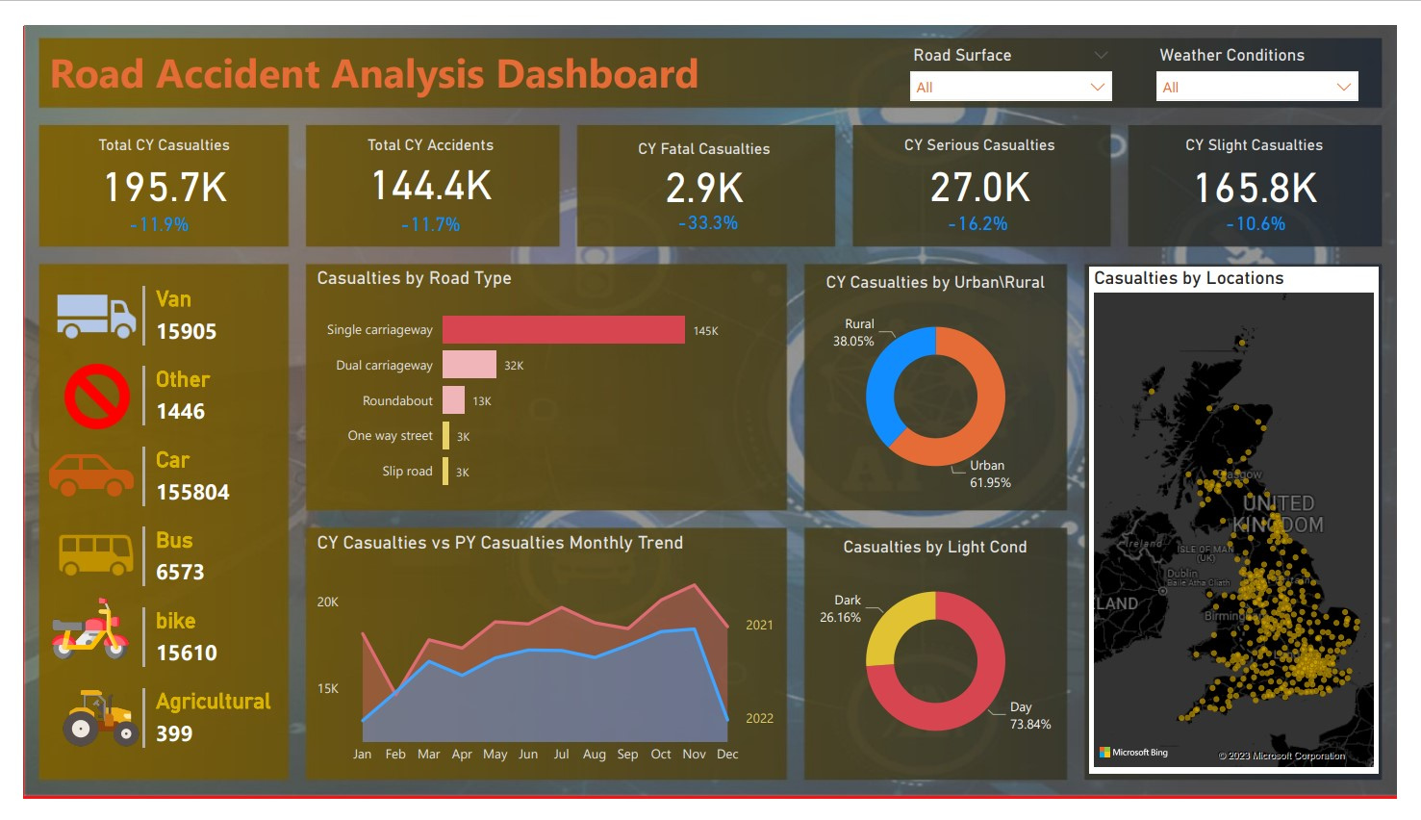

[**click here**](https://app.powerbi.com/view?r=eyJrIjoiYTFlMWMwMTYtNmNlNy00OGNlLWEzMmItZDJjMGE4MDcyZDMzIiwidCI6ImRmODY3OWNkLWE4MGUtNDVkOC05OWFjLWM4M2VkN2ZmOTVhMCJ9)